**Rhythm House**

**E-Project**

Rythm House is one of the best platform for music, live event, live show, CD & DVD.

So contact us and come this platform to enjoy your pleasant life. Thank You

# **Acknowledgment**

Here I gladly present this project documentation on “Rhythm House”. At the Time of submitting this documentation, I use this opportunity to mention those Who are with us along with the work I take this occasion to thank Allah, for Blessing me with his grace and taking my work to a successful end. I want Thanks to my esteemed guide Sir “Sir Ubaid” for providing me with the Right guidance and advice at a difficult part of my project. I would like to thanks to my lovely Friends for the support and encouragement they have given me during the course of my work.

**PROJECT START DATE**

28-Aug-2024

**PROJECT FINISH DATE**

18-Sep-2024

**Group Members**

Student1537911 M.Huzaifa

Student1545861 Abbas Hussain Shah

Student1535218 Tanveer Khan

**PROJECT INSTRUCTOR**

SIR UBAID

**SUBMITTED TO**

ubaidmayari@outlook.com

Contents

**Acknowledgment** 2

**Introduction:** 5

**Objectives of the project** 6

**Problem Statement** 7

**Hardware/ Software Requirements** 9

**SCREEN SHORT** 10

**HOME PAGE** 10

**CD** 11

**DVD** 12

**BOOK & MAGAZINE** 13

**LIVE EVENT** 14

**MEMBERSHIP** 15

**PRICE LIST** 16

**ABOUT US** 17

**CONTACT US** 18

**Introduction:**

The thirst for learning, upgrading technical skills and applying the concepts in real life environment at a fast pace is what the industry demands from IT professionals today. However busy work schedules, far-flung locations, unavailability of convenient time-slots pose as major barriers when it comes to applying the concepts into realism. And hence the need to look out for alternative means of implementation in the form of laddered approach.

The above truly pose as constraints especially for our students too! With their busy schedules, it is indeed difficult for our students to keep up with the genuine and constant need for integrated application which can be seen live especially so in the field of IT education where technology can change on the spur of a moment. *Well, technology does come to our rescue at such times!!*

Keeping the above in mind and in tune with our constant endeavor to use Technology in our training model, we at Aptech have thought of revolutionizing the way our students learn and implement the concepts using tools themselves by providing a *live and synchronous eProject learning environment!*

**So what is this eProject?**

eProject is a step-by-step learning environment that closely simulates the classroom and Lab based learning environment into actual implementation. It is a project implementation at your fingertips!! An electronic, live juncture on the machine that allows you to

* Practice step by step i.e. laddered approach.
* Build a larger more robust application.
* Usage of certain utilities in applications designed by user.
* Single program to unified code leading to a complete application.
* Learn implementation of concepts in a phased manner.
* Enhance skills and add value.
* Work on real life projects.
* Give a real life scenario and help to create applications more complicated and useful.
* Mentoring through email support.

The students at the centre are expected to complete this eProject and send complete project along with the documentation to eProjects Team

Looking forward to a positive response from your end!!

# **Objectives of the project**

The Objective of this program is to give a sample project to work on real life projects. These applications help you build a larger more robust application.

The objective is not to teach you JavaScript/Dreamweaver but to provide you with a real life scenario and help you create basic applications using the tools.

You can revise the chapters before you start with the project.

This project is meant for students who have completed the module of ***Dreamweaver***. These programs should be done in the Lab sessions with assistance of the faculty if required.

It is very essential that a student has a clear understanding of the subject. Students should go through the project and solve the assignments as per requirements given.

Kindly get back to eProjects Team in case of any doubts regarding the application or its objectives.

# **Problem Statement**

Rhythm House is a music store in the city which offers not only music but contests and live shows too. It caters to almost all the age groups by providing the CDs, tapes of poems for kids, latest pop music collection for teenagers etc. Rhythm House also caters to a slightly older age group and boasts of the largest collection of regional and devotional music. Besides, if someone wants to pick up a good 60's or 70's rock album, chances are that he will get it here, and in case it’s not available, they will order it within a week.

They have the largest tape collection one can find ranging from Motion Picture Soundtracks to Rock 'n Roll. Besides music, one can find a number of music related magazines on sale. While some magazines are Indian, most of them are Air Mailed from the US and include top magazines like Guitar Legends and Total Guitar.

They also have a membership facility where in you can enroll yourself against any purchase of Rs. 200 and for subsequent purchases you can avail of points and other offers.

Looking at the growing competition, they have decided to find an easy source to reach to the customer and the solution they thought of is of building a web site which will host all the information about their shop.

They have approached you to develop site by the name rhythmhouse.com for them. The site needs to be developed based on the following set of requirements.

REQUIREMENT SPECIFICATIONS

A menu that will categorize all the functions of the site

Display the list of available albums category wise.

Albums can be of movies or different bands or solo performer’s collections.

Categories can be CD, DVD, Tape as well as movies, bands, Solo performers. E.g there can be CD of a movie as well as DVD and tape, all should be displayed separately.

Perform the search based on a particular

* movie
* band
* solo performer
* release year

Display the statistics of albums sold monthly.

Display the various offers/contests by the shop

Display the details (performer, time, duration, entry fee etc) of live shows

Give information about membership.

Display the available books and magazines.

Display the price list of the various items available in the shop i.e. (CDs, DVDs, Tapes, Books, Magazines)

Display the schedule and details of upcoming live shows.

Site should be able to provide brief introduction/history about the shop under AboutUs page

The location of the shop under Contact-Us page.

Besides the above requirements, the site should have look and feel as per the industry standards

# **Hardware/ Software Requirements**

**Hardware**

* A minimum computer system that will help you access all the tools in the courses is a Pentium 166 or better
* 64 Megabytes of RAM or better

**Software *[Either or Combination as per Course/Seem]***

* Notepad/HTML editor/Coffee Cup
* Angular / Angular JS / React / Bootstrap
* Dreamweaver / Figma
* MS IE / Chrome / FireFox / Netscape /MS Edge

# **SCREEN SHORT**

## **HOME PAGE**

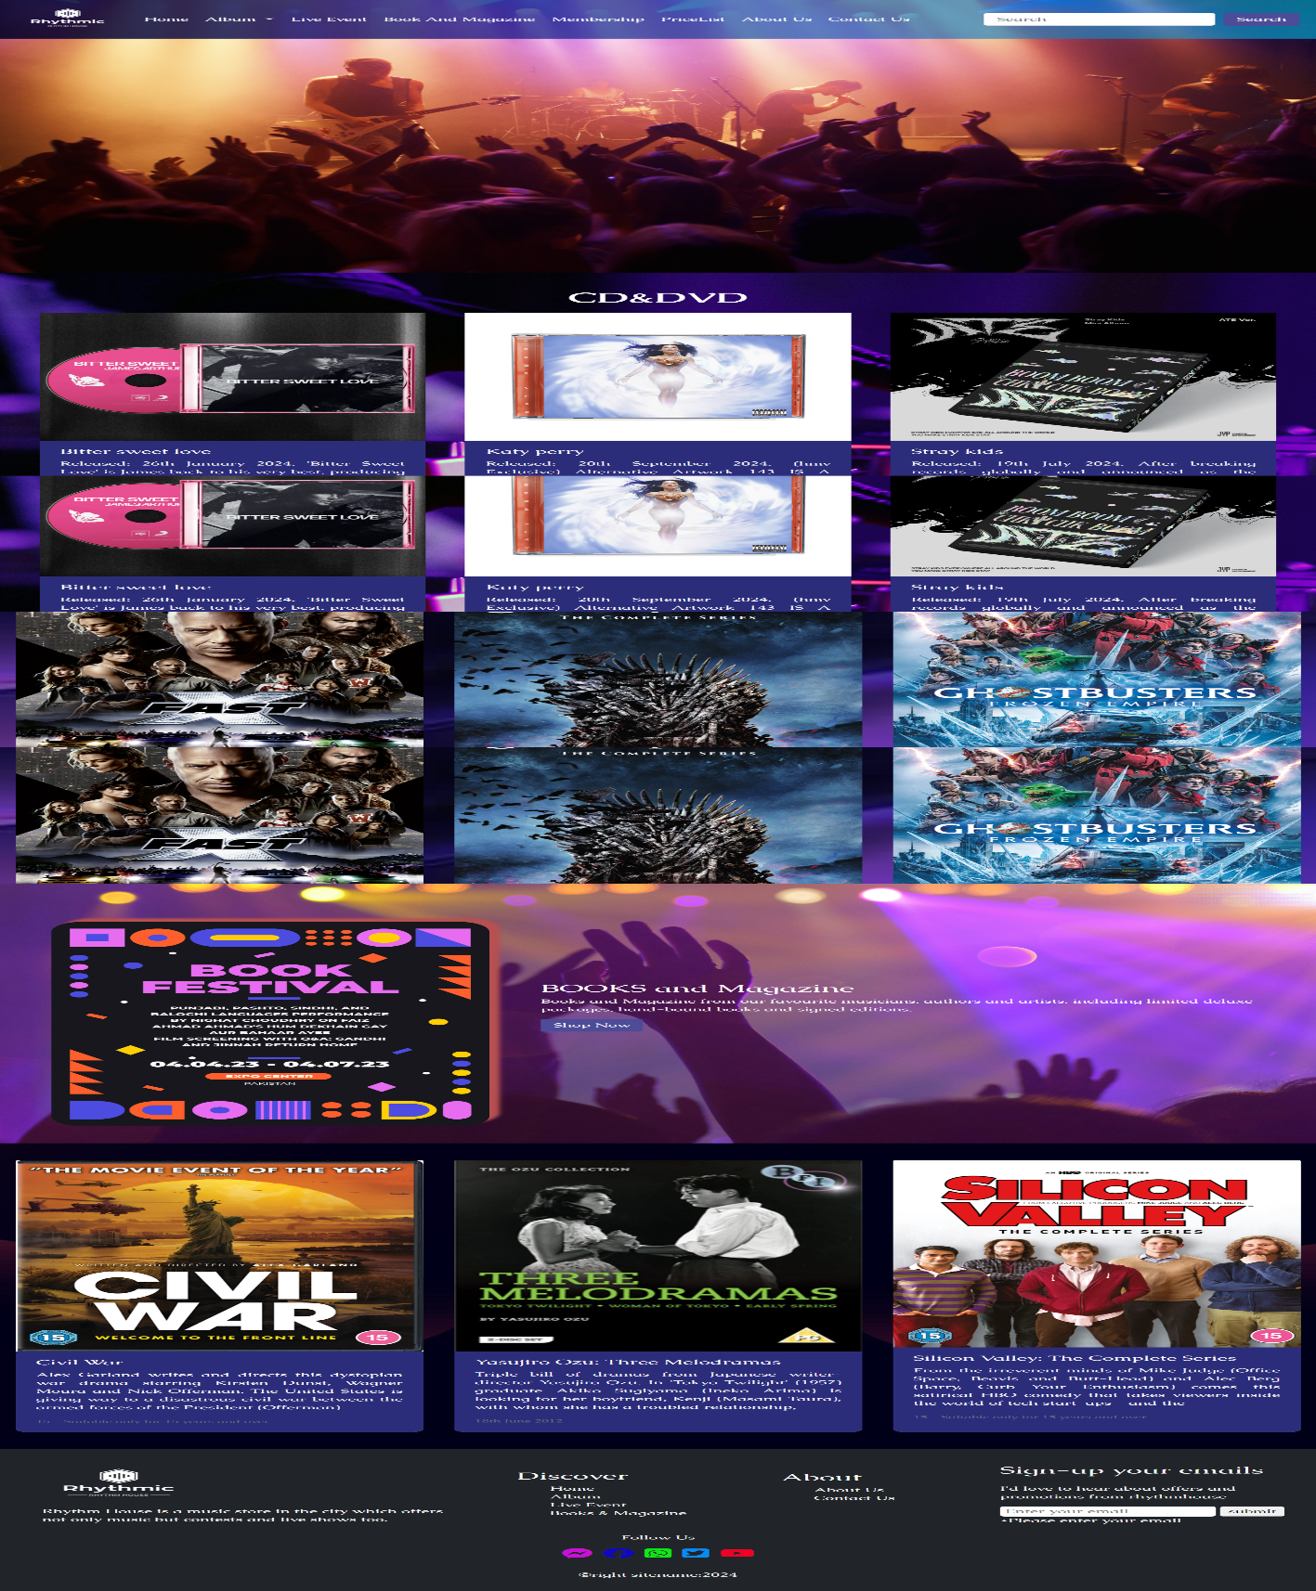

## **CD**

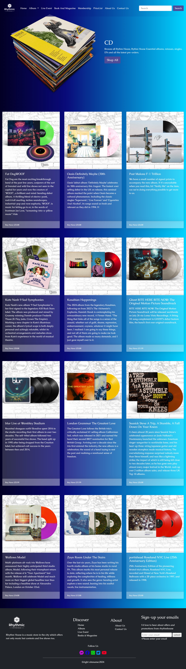

## **DVD**

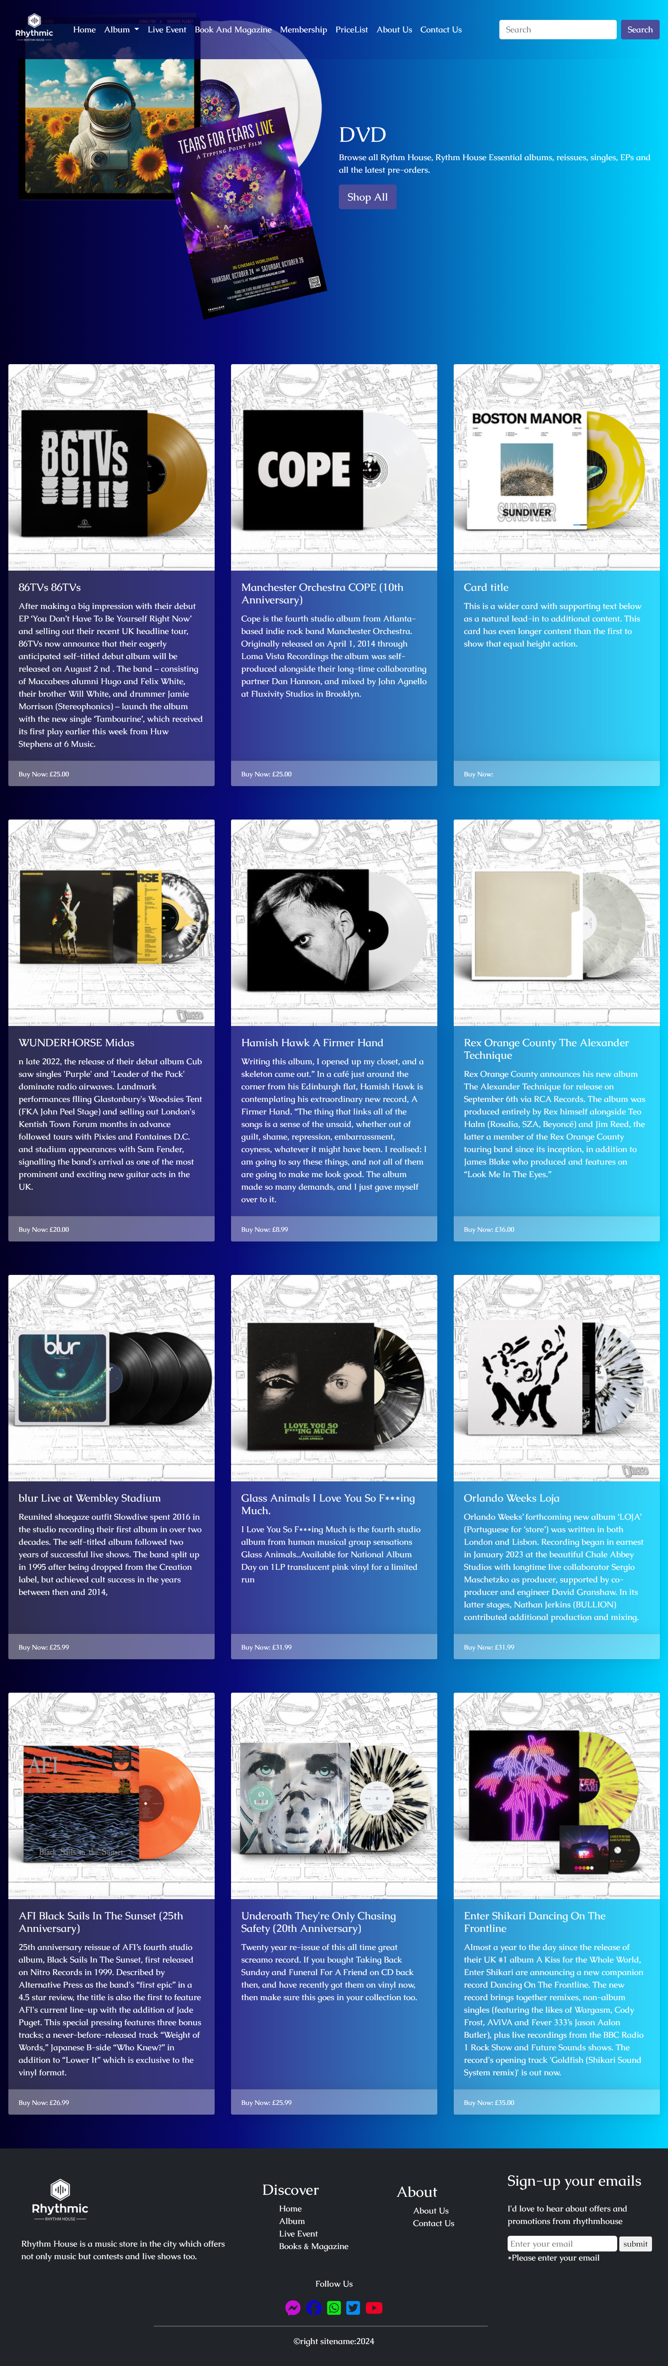

## **BOOK & MAGAZINE**

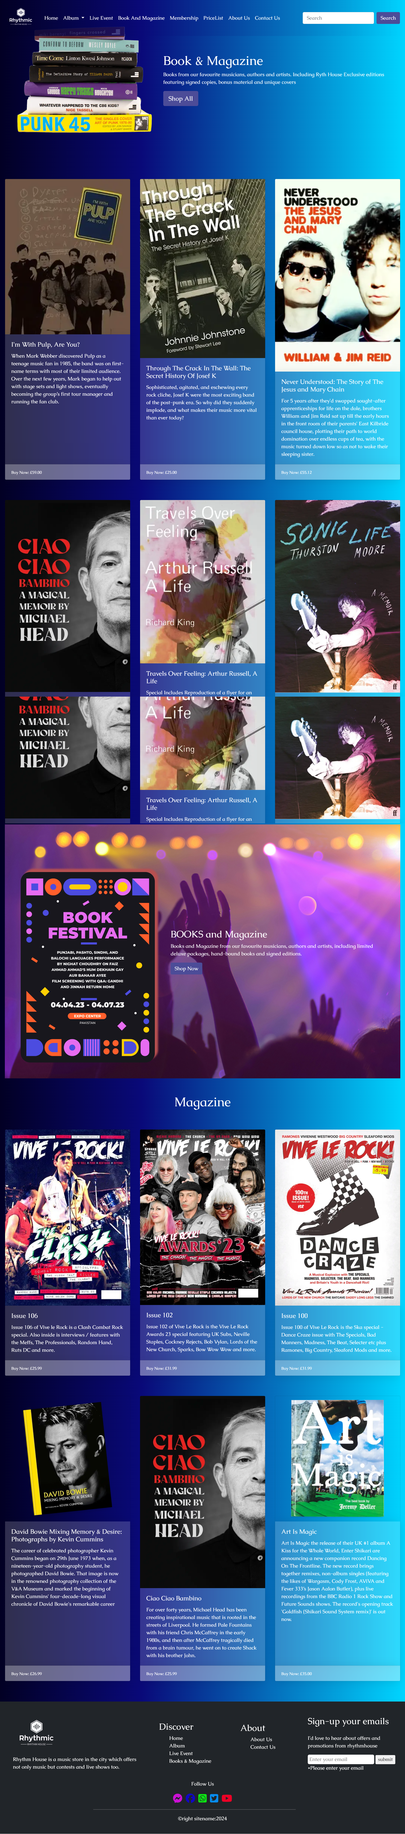

## **LIVE EVENT**

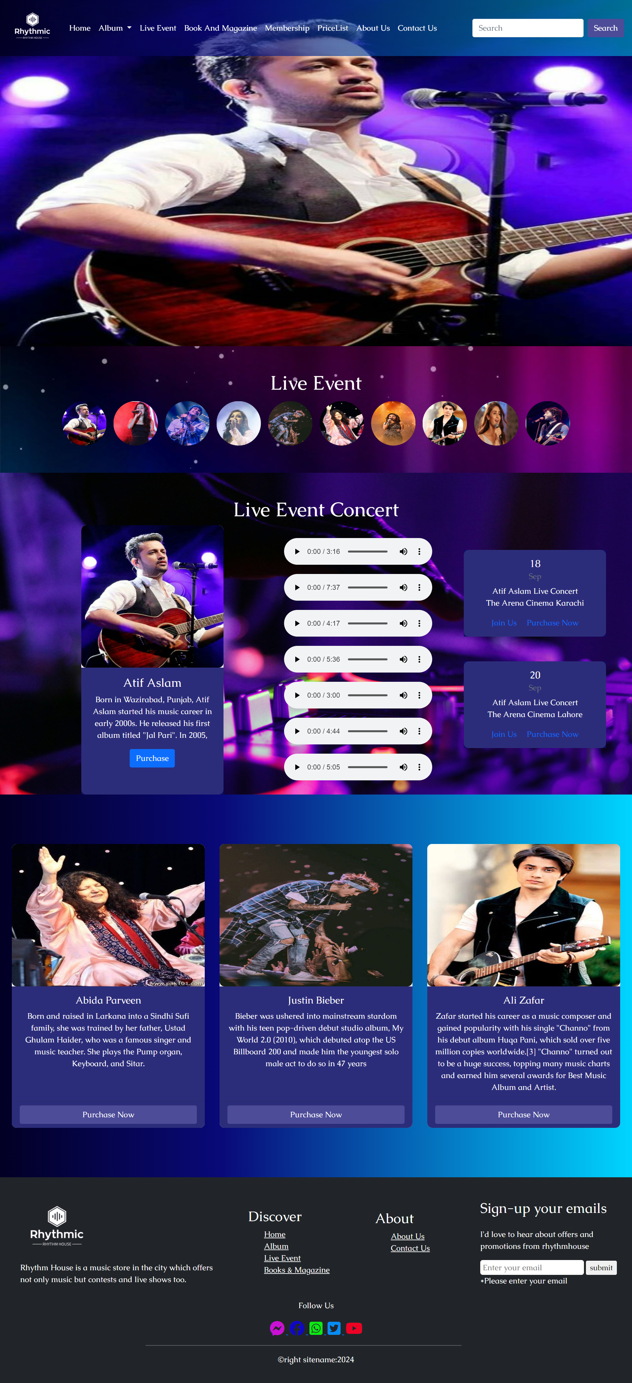

## **MEMBERSHIP**

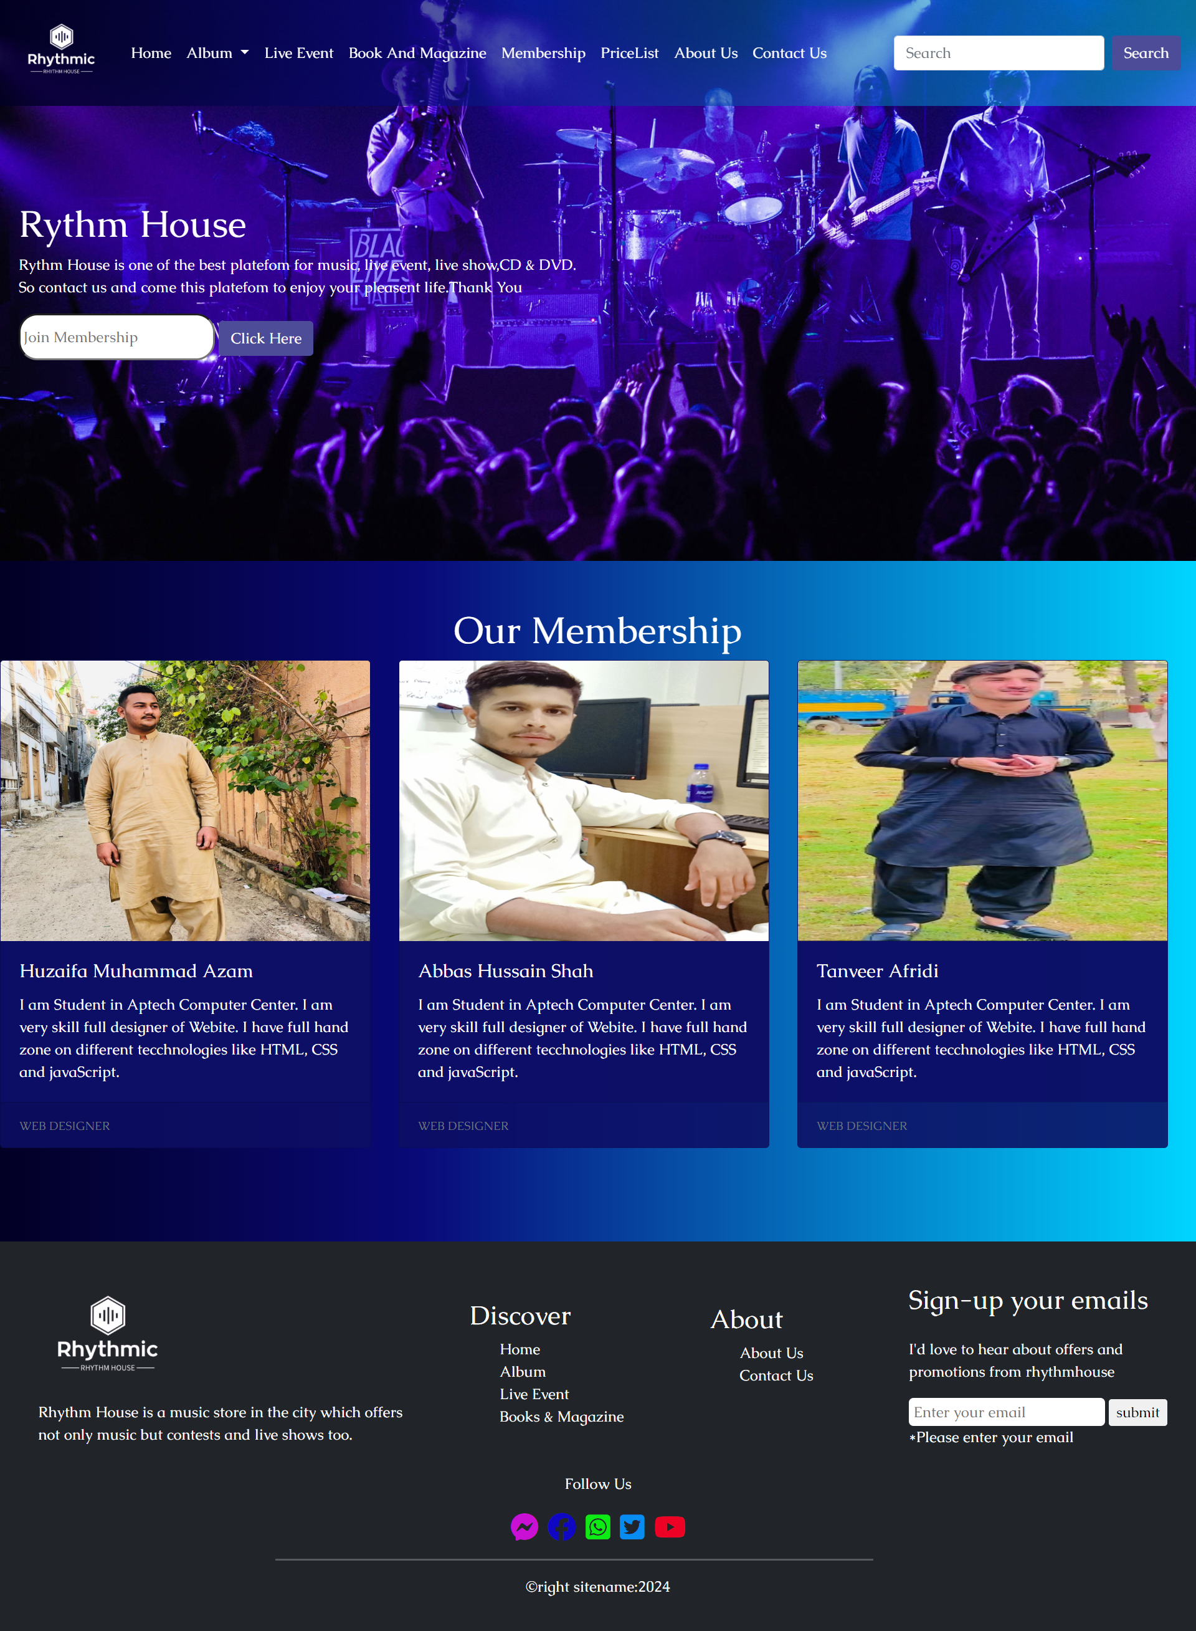

## **PRICE LIST**

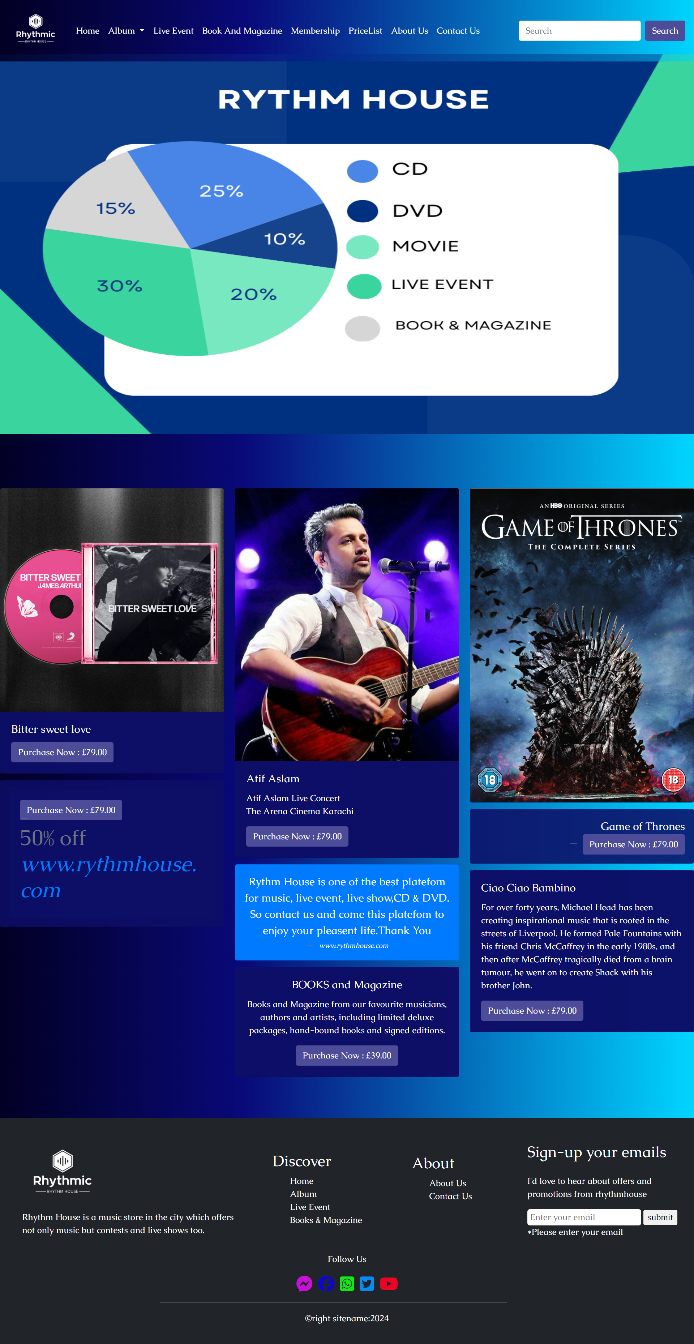

## **ABOUT US**

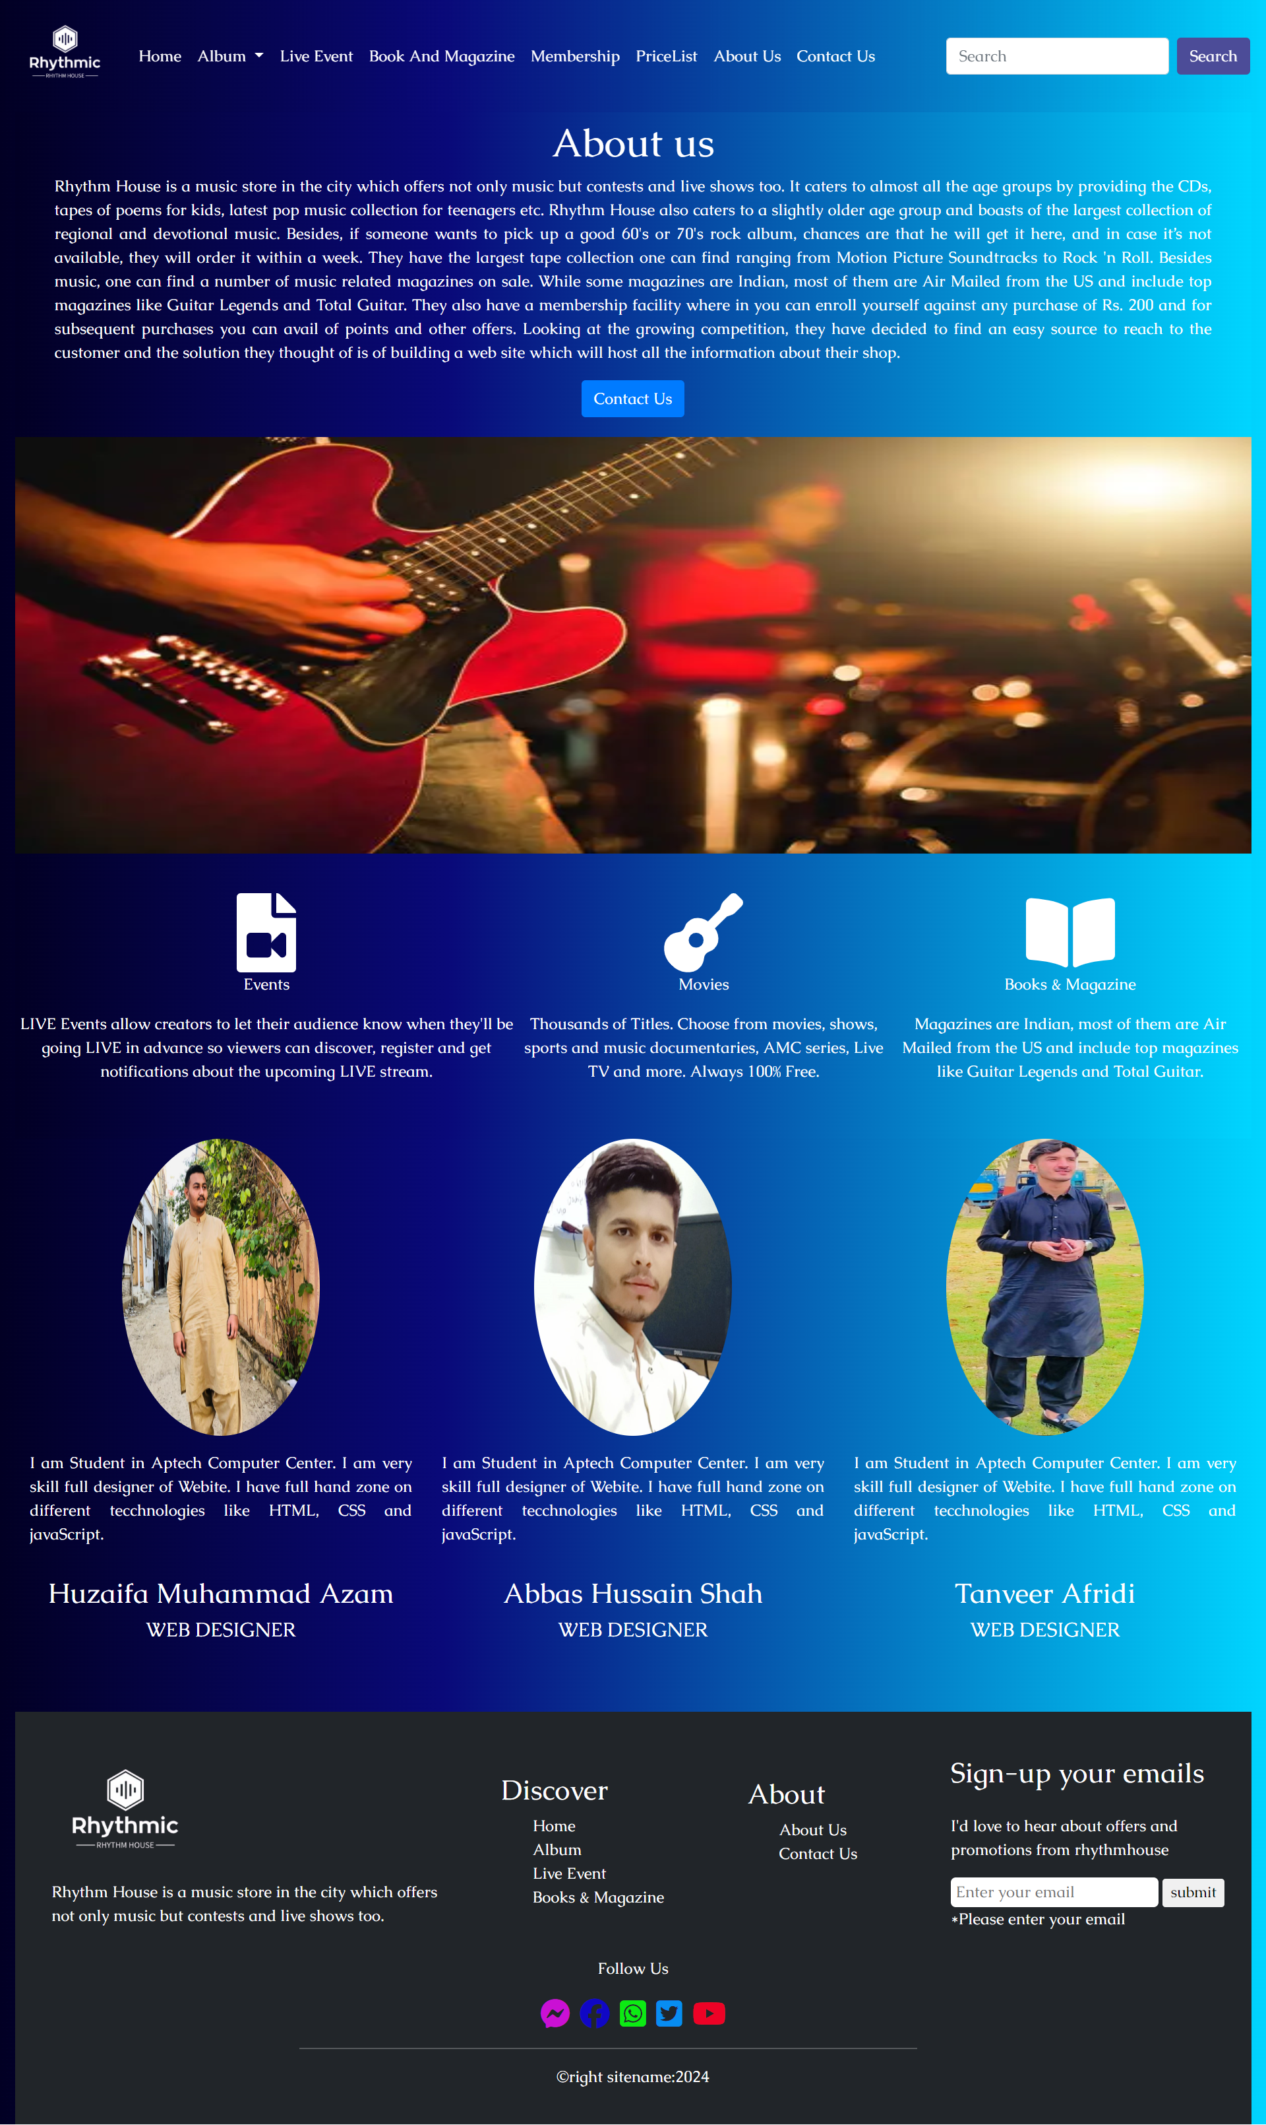

## **CONTACT US**

